Practical No: 8
Study and implementation of Single-Sign-On.
Installation of Josso:
1. Install Java 8 on system as JOSSO requires Java 8 version.
2. Set JAVA_HOME by running following command.
3. Change to the directory where JOSSO’s installation jar file is saved.
4. Start installation by running following command.
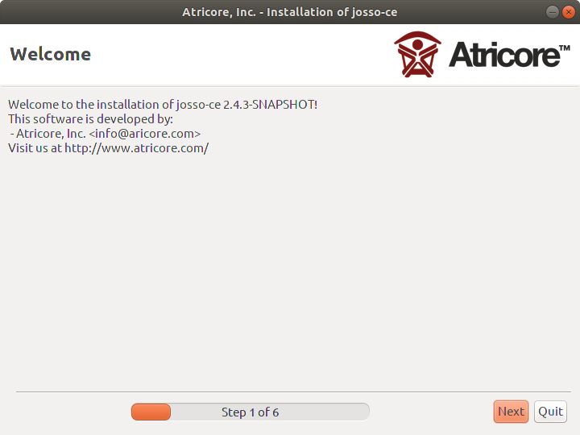

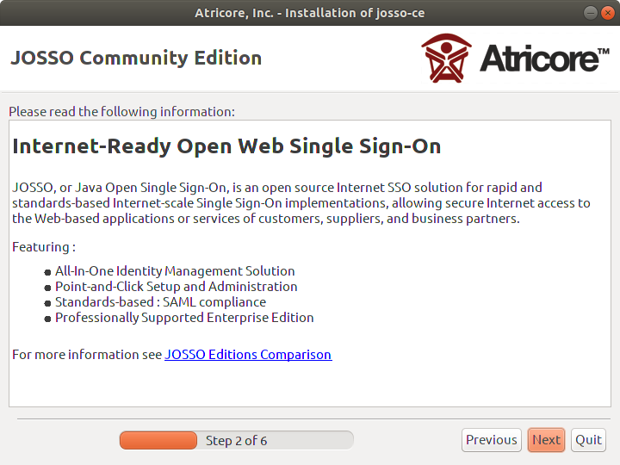

5. Give installation path to JOSSO.
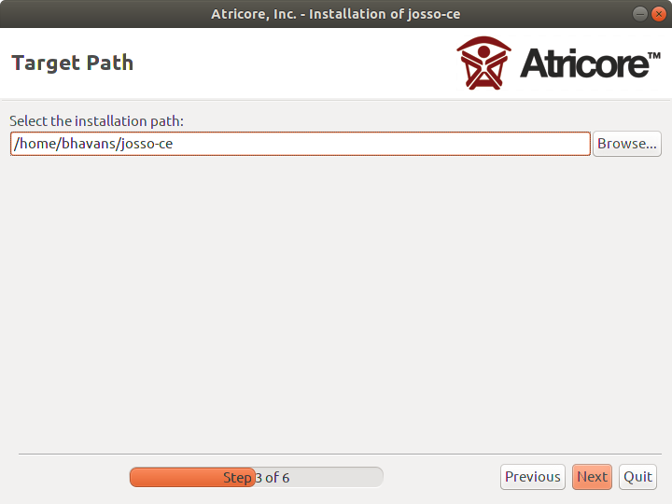

6. Click on Next.
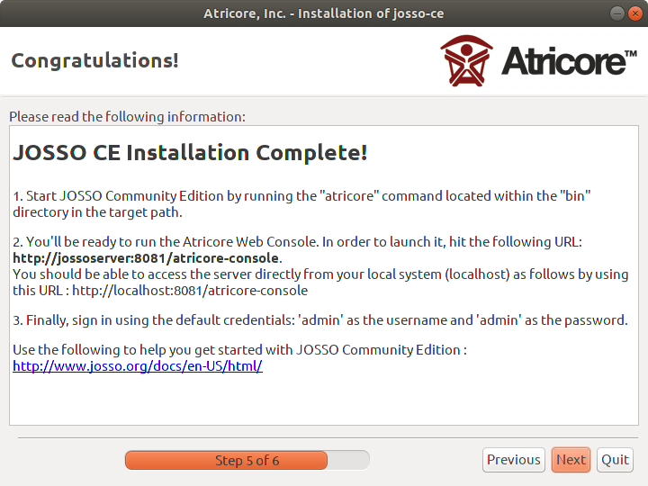

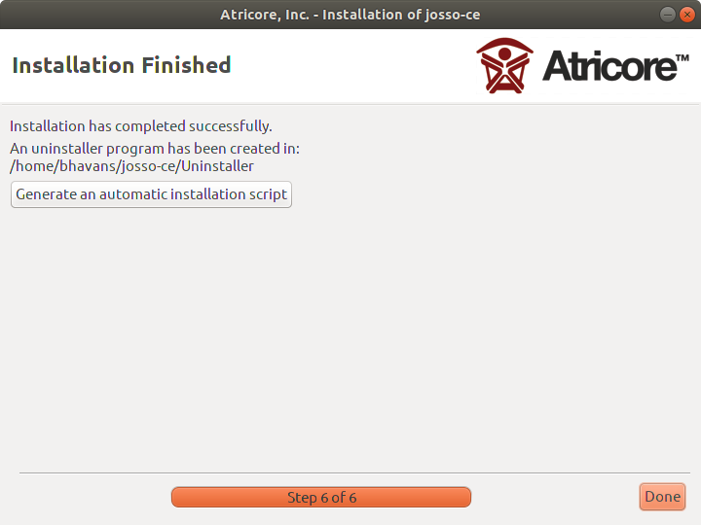

Click On Done

Running JOSSO:
1. Change to the directory where JOSSO is installed.
2. Give permissions for running start up script.
3. Run the script to start JOSSO
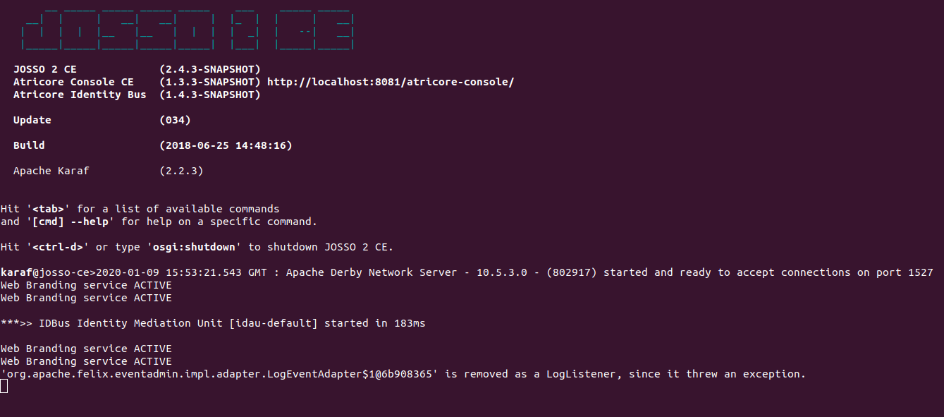
4. 4. 4. 4. 4 4.Open broswer and visit http://localhost:8081/atricore-console/
#You either have JavaScript turned off or an old version of Adobe's Flash Player error #close firefox browser and type
sudo add-apt-repository "deb http://archive.canonical.com/ $(lsb_release -sc) partner"
sudo apt install adobe-flashplugin
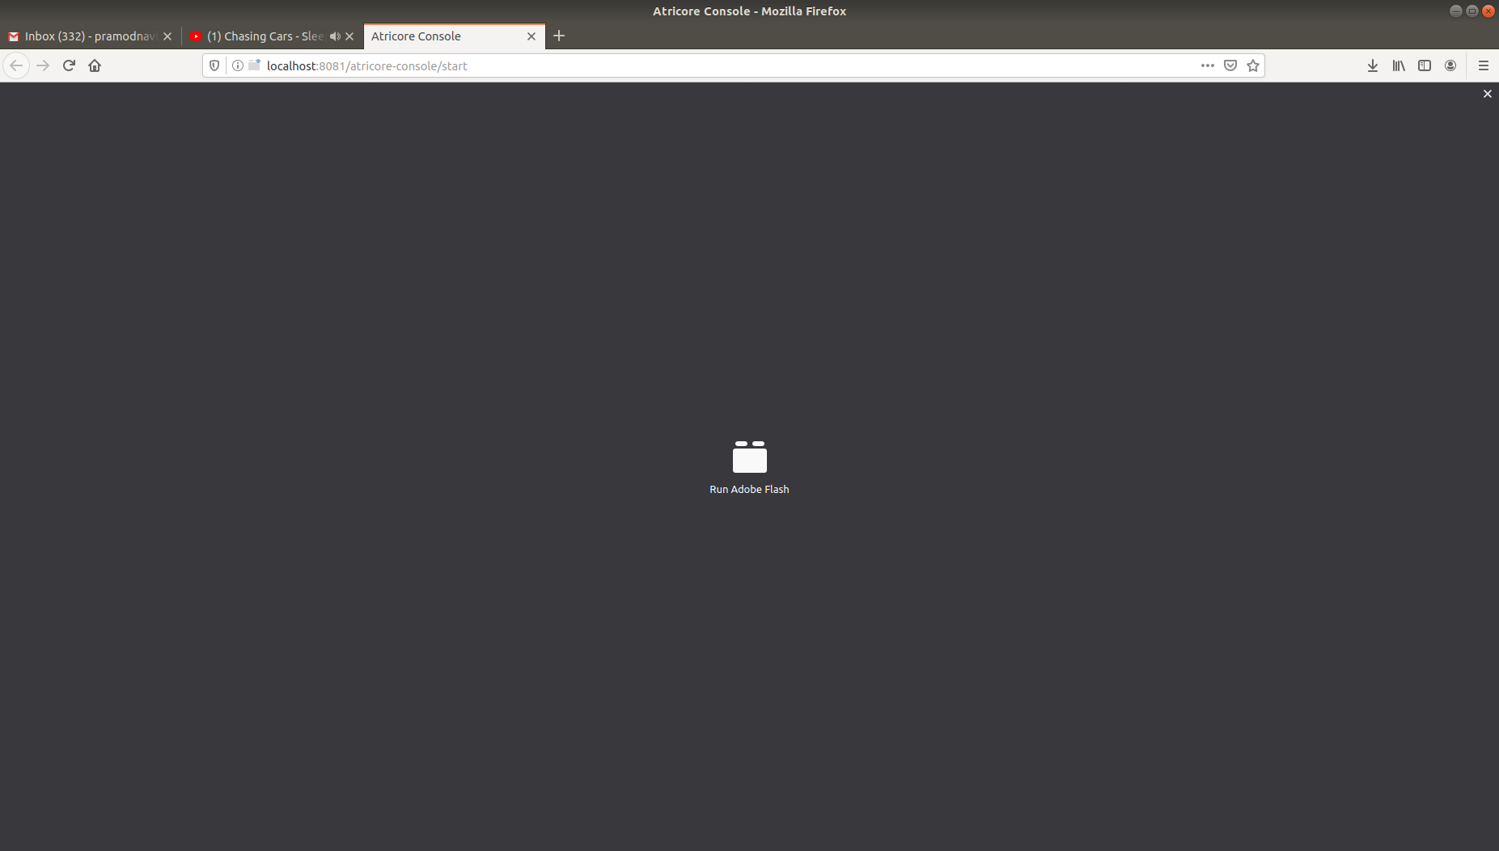
#Click On Run Adobe Flash
#Select Allow

5. Open Firefox broswer and visit http://localhost:8081/atricore-console/ and Login with admin as Username and atricore as the password.
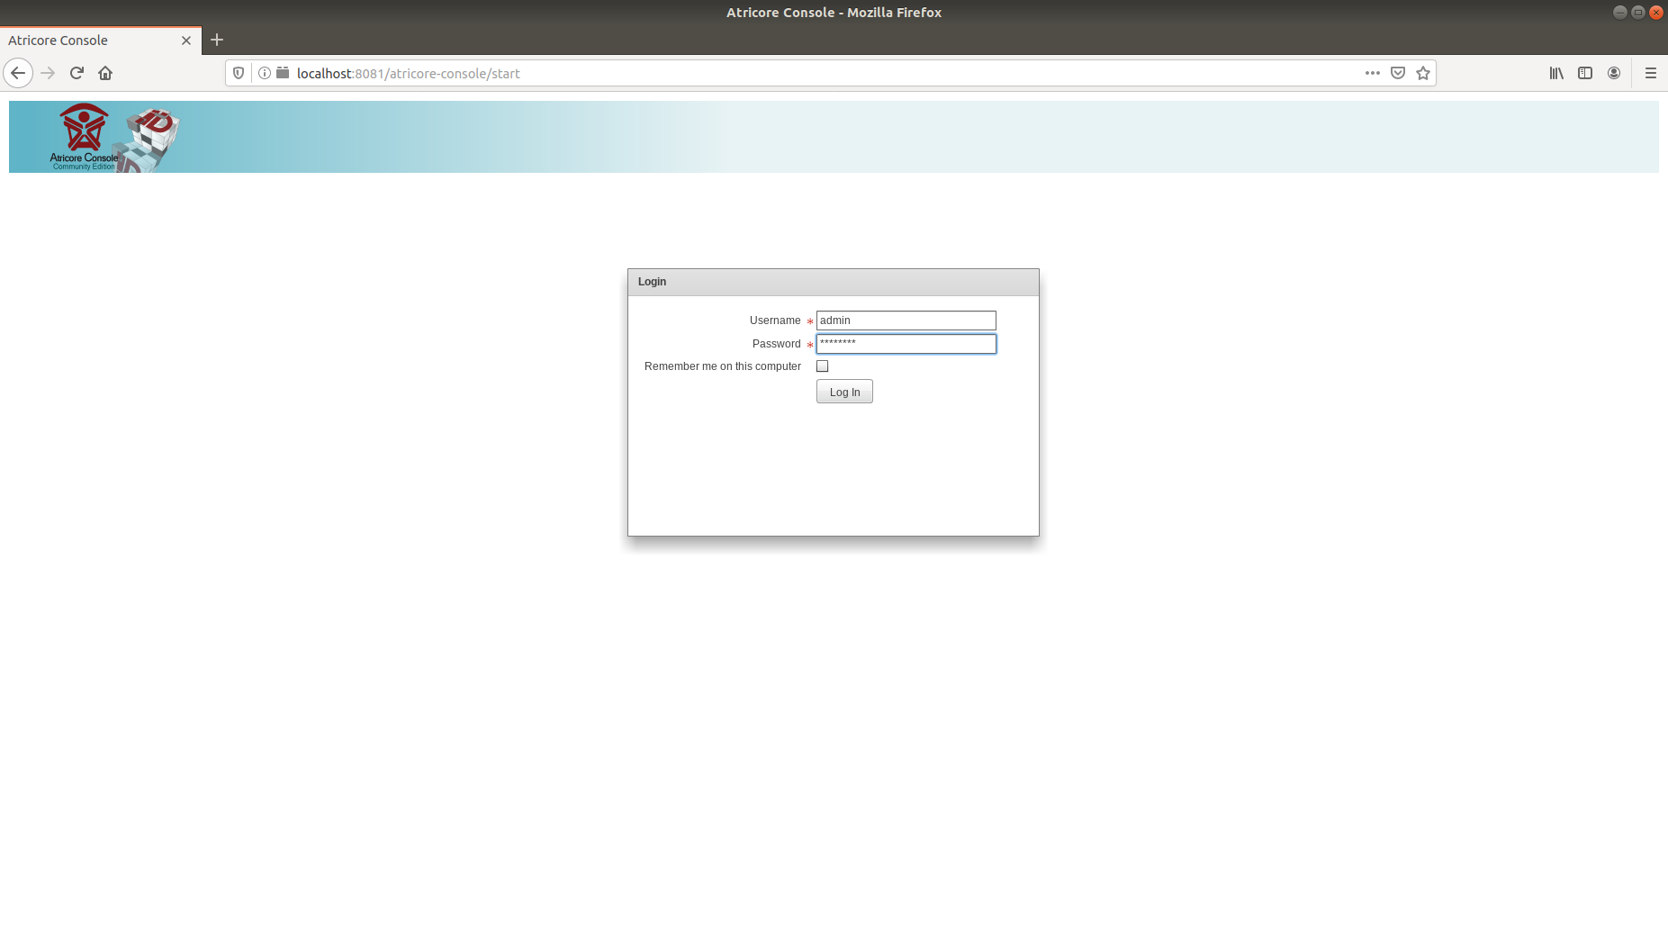
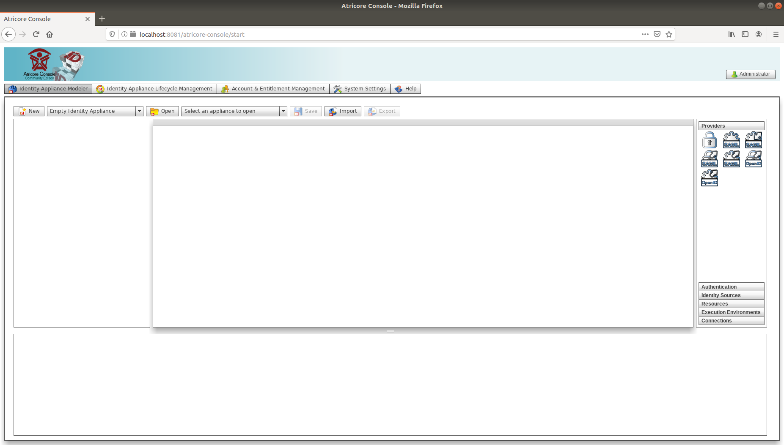
Home Screen of JOSSO

6. Create Identity Appliance by clicking on New Button.
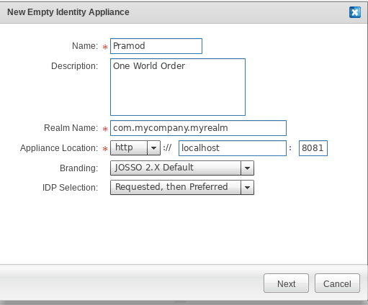

7. Confirm Identity Appliance.
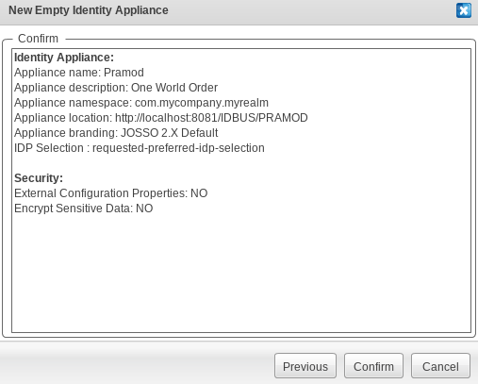

8. For Creating new user switch to Account & Entitlement Management tab and click on
Create User.
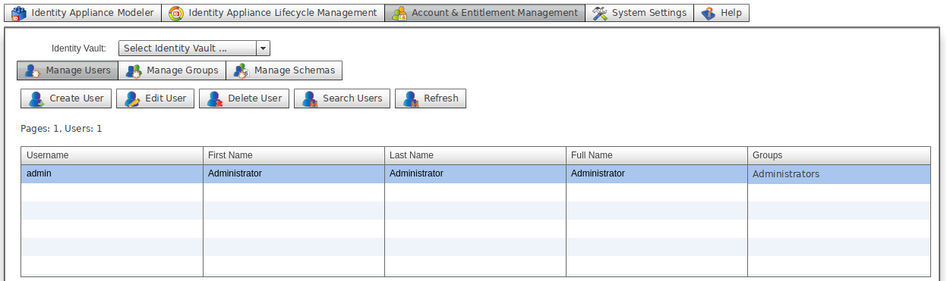

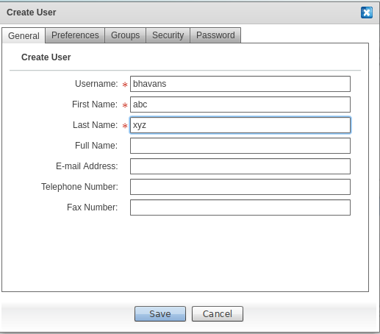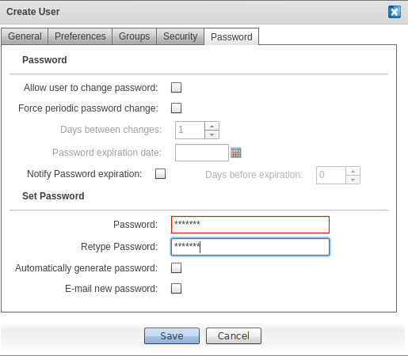

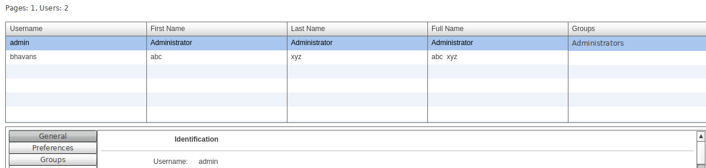

9. Switch to Identity appliance Modeler tab; under Authentication click on Directory Service.
